AIE401 Artificial Intelligence for Educators | Workshop 1

Your Workshop 1 Plan
Wednesday 18 November 2026, 13:30 to 17:00, online in Microsoft Teams
Welcome to AIE401. This afternoon is mostly hands on: you will use AI tools on real teaching material, test what comes back, and leave with the foundations for your action research project. Keep this plan and the resources site open all afternoon.
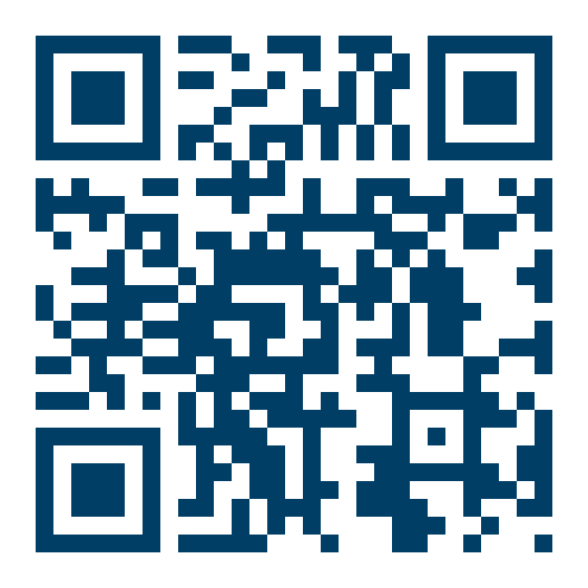 | All your resources in one place  tinyurl.com/AIE401workshop1  Scan the code or type the link. The breakout task cards, your Starting Point diagnostic, the games, the Prompt Lab and the recap are all there, and your progress saves in your browser.

Before we start
- Join the Teams meeting with your camera and microphone working
- Sign in to the college approved AI tool with your institutional account, and check it works
- If you can, use two screens or two windows: one for Teams, one for the AI tool and the resources site
- Have a topic in mind that you are teaching in the next few weeks, because you will build a real resource for it

This afternoon
Time | What happens | What you will use
13:30 | Keynote, Professor Marcello Trovati. Welcome, the module, your assessment and the AI for Educators Summit | AI Bingo on the site
14:00 | What AI actually is. Four families of AI, how generative AI writes, and a quiz | AI or Not? on the site
14:25 | Your starting point. The AI Digital Skills Check, the Starting Point diagnostic, and setting up your reflective journal | AI Digital Skills Check, Starting Point and the Reflective Journal
14:40 | Breakout one, Prompt Relay. Turn a weak prompt into a resource you would actually use | Breakout Room Companion, card one, and the Prompt Craft Card
15:15 | Break, ten minutes
15:25 | Breakout two, Mark the Machine. Mark a fictional answer yourself, then compare with the AI | Breakout Room Companion, card two
16:00 | Breakout three, One Resource, Five Learners. Adapt a text for different learners | Breakout Room Companion, card three
16:30 | AI literacy. What staff and learners need, and integrity by design | The Teams chat
16:45 | Close. Draft your practice problem, plan your directed study, exit ticket | Reflective Journal and the exit ticket Form

In the breakout rooms
Each room has four or five people from different subjects and settings. Roles rotate so everybody drives the AI tool at least once. The Breakout Room Companion can spin for roles and time each step.
Role | What you do
Prompter | Shares screen and types into the AI tool
Critic | Tests the output against the critique checklist
Subject expert | Judges accuracy and level for real learners
Reporter | Captures the outputs and posts them in the Breakout outputs channel

Ground rules
- No real learner work, learner names or personal data go into any AI tool. Everything we use today is fictional or your own material
- Everything AI produces is a draft until someone with subject knowledge has checked it
- Cameras on when you can, questions in the chat at any time, raise your hand to speak
- Disagreement is welcome. The best discussions today come from different settings seeing things differently

You leave with three things
1 | A working reflective journal, saved somewhere you can find again
2 | A completed Starting Point diagnostic and initial AI Digital Skills Check, both uploaded to Canvas
3 | A first draft of your practice problem, the seed of your action research project

After today
- Use the Workshop 1 Recap on the site: flashcards, a knowledge check, the glossary and your directed study tracker
- Post in the Introductions channel of the Teams Community of Practice, if you have not already
- Work through the Directed Study Pack before Workshop 2, around twelve to fifteen hours
- Bring your institution's AI policy, one live assessment and your practice problem to Workshop 2
Keep the link. tinyurl.com/AIE401workshop1 stays live after the session, so you can come back to any of the resources whenever you need them.

